

PARS Reporter – RBM User Guide

Overview
The PARS Reporter RBM extension enables Project and Program officers to collect both qualitative and quantitative Results Based Management information on a per Project Activity basis. This extension to PARS Reporter allows you to continue to collect Project Activity information and also collect additional RBM related data in the same database, thereby lessening the data maintenance requirement for reporting.

Once enabled, the RBM extension requires some minor setup of Sector and Indicator relationships. Subsequently, RBM data is collected on a per Project Activity basis.

RBM output reports are available on a per Project Activity, per Program and on a per Sector basis. All reports are designed as word processor RTF format templates. These templates can be amended to suit your own needs. Other reports can be provided if desired; please contact Nufocus for details.

RBM Sector-Indicator Setup
Prior to collecting any Sector-Indicator RBM reports, the list of indicators must be set up on the PARS Reporter Utilities screen.

It is very important that you spend sufficient time prior to entering this setup data to define the Sector-Indicators that you wish to track. Changes in the future, once you have entered considerable amounts of data, can be time-consuming.

Go to the PARS Reporter – Utilities tab and Click on the RBM Setup button to display the Sector – Indicator Definition listing. Click on the Add and/or Remove buttons at the base of the list to change list content.

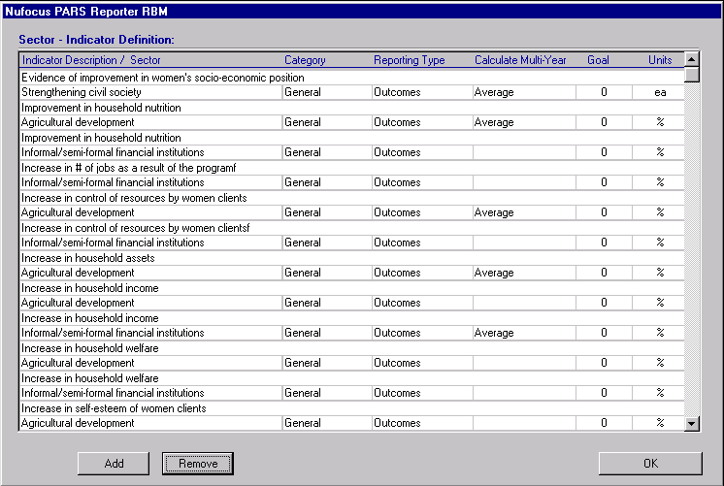

Double-click on a list entry to edit the Indicator, Sector, Category, Reporting Type, Goal, Units and total calculation settings..

Type in your descriptive Indicator title. Use 80 characters maximum.

Chose a Category of either General or Specific. This has no present effect on the reports in PARS Reporter RBM, but can be used to categorize indicators in listings.

Set the Reporting Type to either Outputs or Outcomes. This will place the indicator in either of these 2 areas in the roll up reports generated by PARS Reporter RBM.

Set the Calculate Multi-Year Totals By field to “Sum”, “Average” or “Last non-zero” depending on the type of total you wish to display for the 5 Year totals on the custom Indicator RTF reports that are available in PARS Reporter RBM. For example, the Sector Indicator Summary displays 5 years of quantitative indicator data. For certain indicators such as a percentage of population, you may wish to display a 5 year total that reflects the Last non-zero amount. On the other hand, a beneficiaries count indicator would likely be summed over the 5 year period.

Set the Calculate Multi-Activity Totals By field to “Sum” or “Average” depending on the type of total you wish to display for the column totals on the custom Indicator RTF reports that are available in PARS Reporter RBM. Similar to the above paragraph, a total for a count-based metric would best be set as “Sum”, but a ratio or percentage would likely be best set as an “Average”.

Note that if you click on the Indicator Description / Sector column header in the RBM Setup list pictured below, the sort order will alternately change from Indicator to Sector and back.

Once you have completed this setup, the Auto-Load feature on the View RBM screens can be used to populate an Activity with this default Indicator data. Also, the Add Indicator button on the Activity, View RBM, Metrics screen will display a list of these Indicators to add to the particular Sector analysis on the activity.

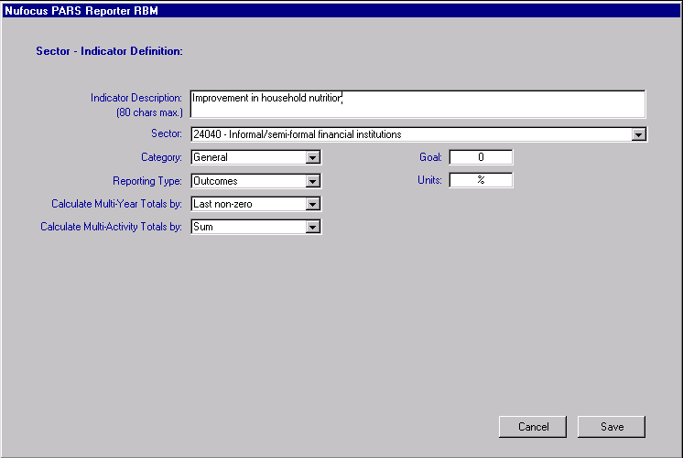

Project Activity RBM Data Entry
Once you have set up the Sector – Indicator relationships, then you can begin entering RBM data for the individual Project Activities. To edit this information, navigate to the Activity Tab and select an Activity on the Activity List and then click on the View RBM button on the right of the listing.

The Activity RBM Information screen will be displayed. This screen has 8 tabs of information. The Internal Narratives page allows you to capture textual data related to the chosen Activity that is internal in scope. Use the Constituency Narrative to capture text that you may wish to share with partners and funders, etc. The Management Narrative should be used to capture internal project activity management issues.

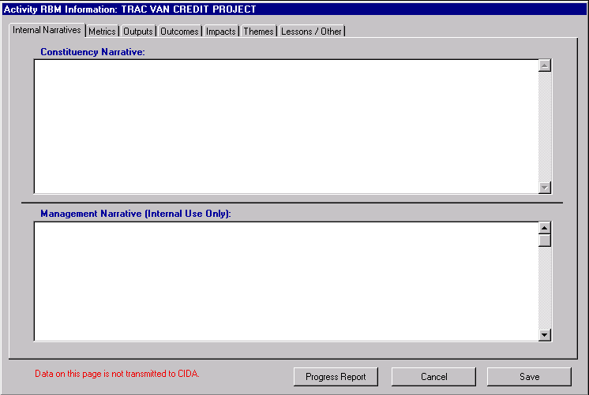

The Metrics tab enables you to monitor particular sector-related indicators. The Sector popup will only display Sectors that have been assigned to this Activity in the PARS side of PARS Reporter. Navigate to the PARS side by returning to the Activity List, and double-clicking on the Activity in the list. Then click on the Sector tab and assign the appropriate Sector to the Activity. Once you have done this, you will be able to return to the RBM Metrics screen and set the correct Indicators. See the RBM Sector – Indicator Setup section above for further details.

To auto-load the Indicators, select the desired Sector and fiscal Year, then click on the Auto-Load button. A dialog requesting you to choose the type of Load function required is displayed:

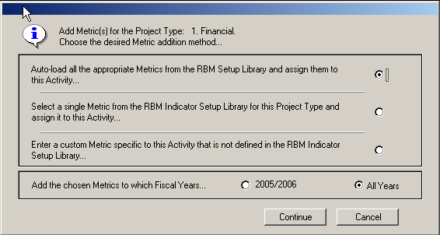

You can elect to Auto-load all Indicators from the RBM Setup Library that match the Sector choice on the RBM Metric screen, or you can elect to load an individual Indicator into your Metrics List. You also have the option of manually entering a Metric. This is not recommended if you wish to perform cross-activity metric analysis.

You also need to select a single fiscal reporting year or all years for the Activity in question using the ‘Years’ choice buttons.

Once you select your load option and the years to auto-load, then you will be prompted to confirm your action (see below). Click on the Auto-load button on the dialog to continue with the loading process. When complete, the list will contain all Indicators that have been assigned to that Sector in the RBM Setup screen found on the PARS Utilities tab.

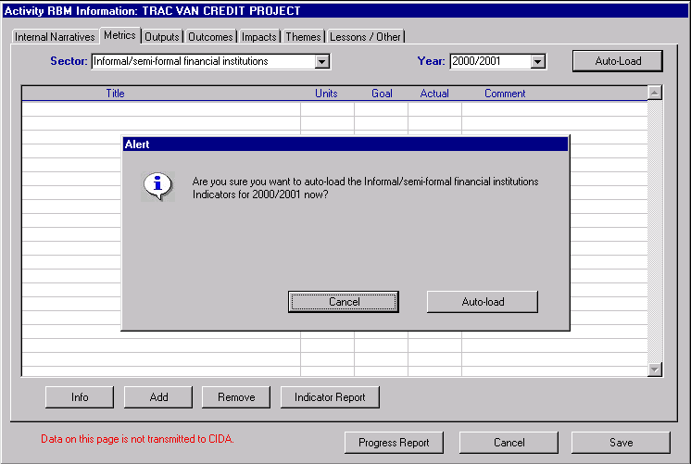

You can then amend the Goal and enter Actual data in the columns provided. Do not edit the title or units. This should be done in the RBM Setup whenever possible. A short comment can also be captured for each indicator.

Notice the presence of the Progress Report, Indicator Report and Profile Report buttons on the RBM data entry screens. These reports provide Activity specific views of the RBM data. If you click on either of these buttons, you will be prompted to save a file. This file will be a fully editable word processor file that you can use for either internal or external reporting purposes.

The Outputs tab has 4 text fields. Please fill these fields with up-to-date Output information for the chosen Activity. These fields will map into the appropriate fields in the word processor export document.

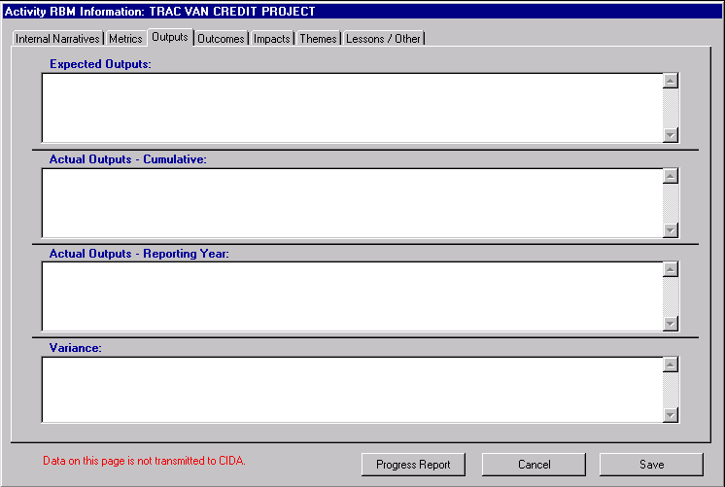

The Outcomes tab has 3 text fields. Please fill these fields with up-to-date Outcome information for the chosen Activity. These fields will map into the appropriate fields in the word processor export document.

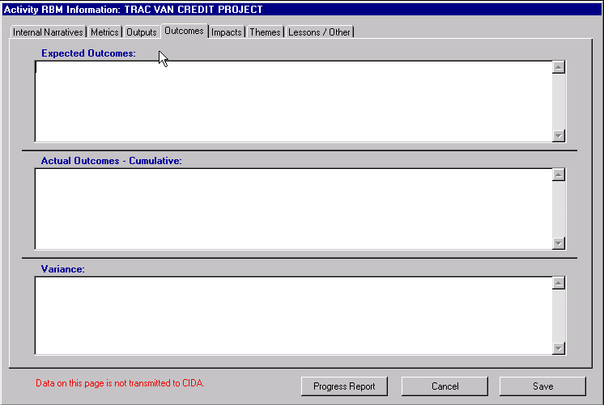

The Impacts tab has 2 text fields. Please fill these fields with up-to-date Impact information for the chosen Activity. These fields will map into the appropriate fields in the word processor export document.

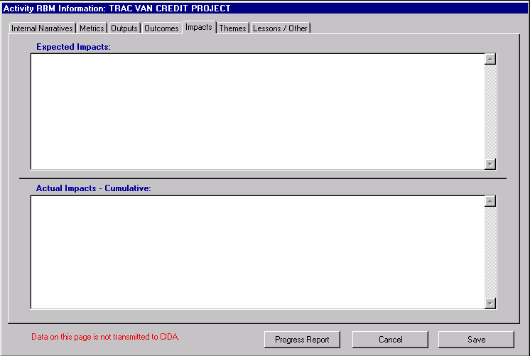

The Themes tab has 1 choice list and 2 text fields. Select a Theme from the list, and then complete the 2 fields with up-to-date Theme Outcome information for the chosen Activity. These fields will map into the appropriate fields in the word processor export document. Note that you can Add and Remove themes from this list. Be aware that the Themes listed here are the same Themes that are listed on the PARS side of the database. Do not add themes here unless you wish to report these themes to CIDA.

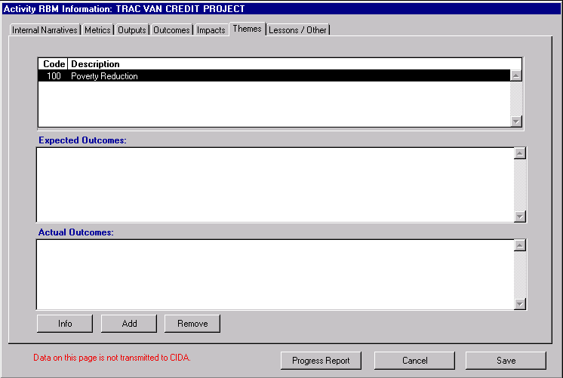

The Lessons / Other tab has 2 text fields. Please fill these fields with up-to-date information for the chosen Activity.

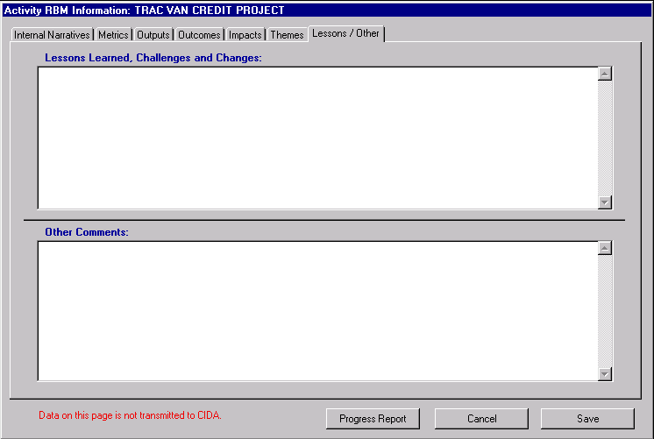

RBM Reports
Project Activity level RBM reports are available from within the View RBM Activity screen by clicking on either the Progress Report or Indicator Report buttons.

For Program Reports return to the PARS Reporter main Navigator screen, and then click on the Program Tab. In the bottom you will see four Report buttons.

Click on the Indicator Summary button to compose an Indicator Summary for the chosen Program. You can elect to see all Sectors (or Types), all or one Partner and you also can focus in on a single Indicator in this report.

Click on the Program Narrative Report button to compose a Narrative Summary for the chosen Program. You will be prompted to choose all Sectors (or Types), and all or one Partner prior to composing the summary report.

Click on the Program Metric Pivot Export button to compose an Excel spreadsheet containing all the Metric information for the chosen Program. This can be used to generate a Pivot Chart or Table using Excel.

Click on the Program Commentary Export button to compose a word processor document containing commentary information for the chosen Program(s). This can be used to quickly assemble annual reports or other high level documents.

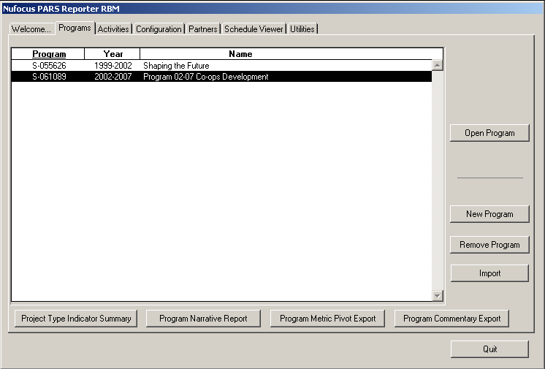

Further Support
If you require further support or have other questions or comments about PARS Reporter, please forward these comments to: dgarrard@nufocusinc.com Your questions will be dealt with within one business day.

PARS Reporter is custom software and can be further customized to fit your particular needs. Please address your customization issues to: dgarrard@nufocusinc.com

